**Plans for today:**

Along with attendance today, I will be passing out a signup sheet for midterm meetups, and will ask students to provide days of availability to see me during office hours this or next week. I will be sending emails out with scheduled times to meet with everyone who signed up.

Today, I will be helping out students with their lab projects, and since both sections have the same one, everyone will be working together this time. I plan on asking the students whether they would prefer to work in small groups or if they would rather go through chunks of code together as a class.

If working in groups, I will go around the room and occasionally checkup on how everyone is doing. I might have students share their own solutions on how they implemented a method with each other. Further, I’m thinking of breaking up the class into small sections so that they can each tackle different methods. We could then regroup and share the different methods with the rest of the class.

If the majority of students would prefer me to go over some specific methods on the board, I might start out by describing what needs to be done using pseudo-code. From there, I would ask the students to finish the method either in groups or on their own, as I walk around checking their work.

**What happened**:

I talked about the midterm meeting today, making sure to have students write down their times of availability as well.

After that, we jumped right to the project. I first asked how many students looked at the project, and then whether anybody had started the project already. Not many had started, so I decided to briefly go through what the program was all about. I made sure to cover everything while keeping it brief, so that we could get enough time to start on the code. It took about 15 minutes to get through all of this.

I then asked whether the students wanted to start working on methods as individual groups, and absolutely nobody raised their hand. Everyone unanimously wanted to work one the assignment as a class. I got started by outlining each of the methods that we would need to create based on the outline that I had created on the board already. I then shifted the class to focus on one of the methods that would help us to solve the more complicated methods. I made sure to stop every five minutes while explaining the concept on the board. I then moved to the computer to type everything out that I explained on the board, and also stopped in between then to recap everything that we just went over on the board. I made sure to run the code in the end to show everyone that the proposed solution actually worked. I told the students that I will be emailing them the code later today for them to take a look at it.

For homework, I told students to finish up a few of the other simpler methods that rely on the method that we covered in class. I told them that we would be looking at the more complicated methods on Wednesday and will attempt to wrap up the rest of the project on Wednesday, before it is due on Thursday.

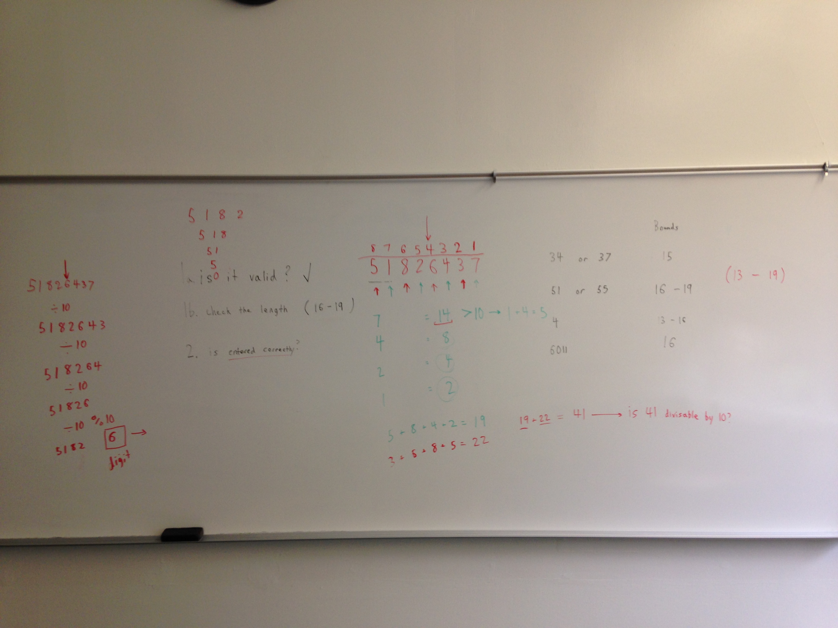

Conceptual Board Work: I went over the everything that we would need to be programming for the project. I made sure to outline the order in which these processes would need to take place in the code.

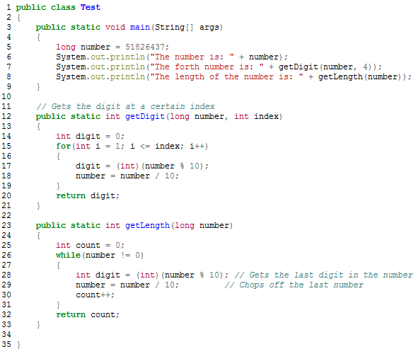

The code that I will be sending out by email. I will be removing most of the code inside the method, but will be leaving in the comments to guide students how to get to the solution themselves based on what we covered in class today.